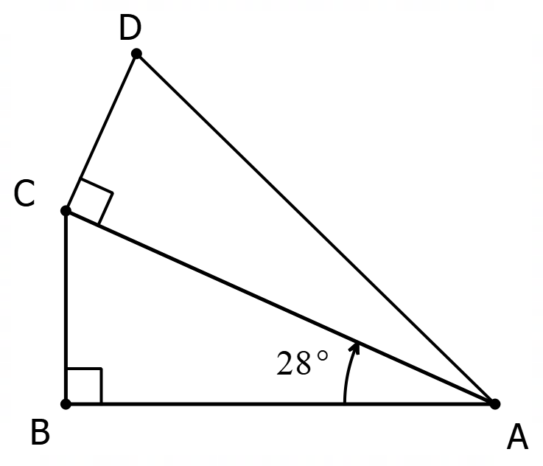
Right Angle Trigonometry – Challenge Questions
1. The two triangles below have the same area. How large is angle CAD?

2. This time, the two triangles have the same PERIMETER. Again, how large is angle CAD?

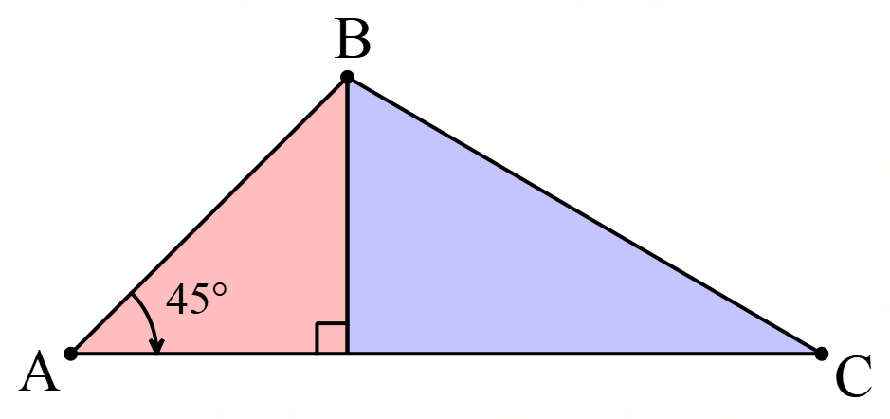

3. This triangle has been divided so that the area of the blue (right) side is 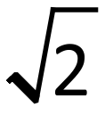 times the area of the red (left) side. What are the angles of triangle ABC?

4. A cone is produced by removing a quarter of a circle and joining the two edges. When you look at the code from the side, what angle is formed by the two sloping sides?
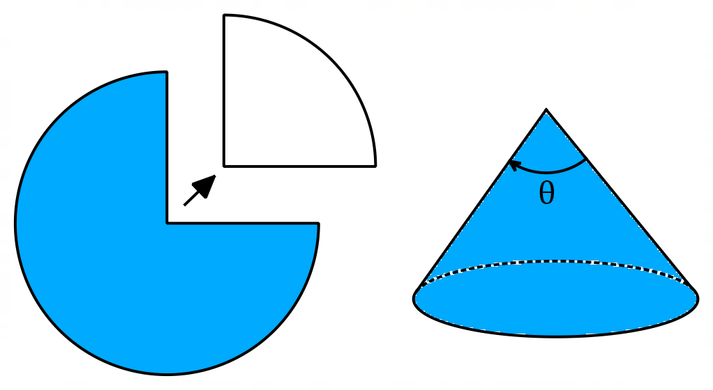

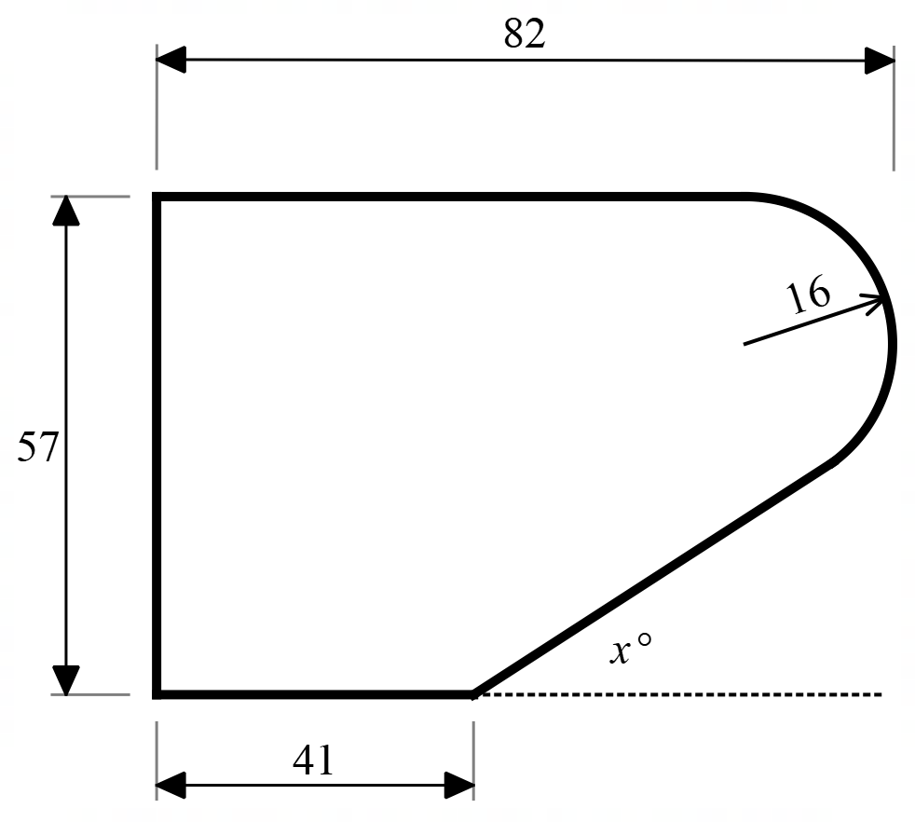
5. A kitchen supply company is designing a new edge-moulding for benchtops that has this design.
All distances are in millimetres. You can assume that the straight edges are tangential to the rounded corner. Find the size of angle x.

Right Angle Trigonometry – Challenge Questions - Answers
- 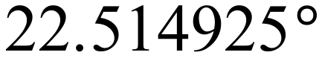
- 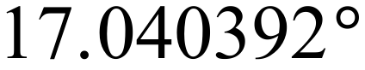
- 45°, 35.3° and 99.7°
- 97.2°
- 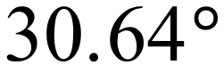

Right Angle Trigonometry – Challenge Questions - Solutions
1. The two triangles below have the same area. How large is angle CAD?
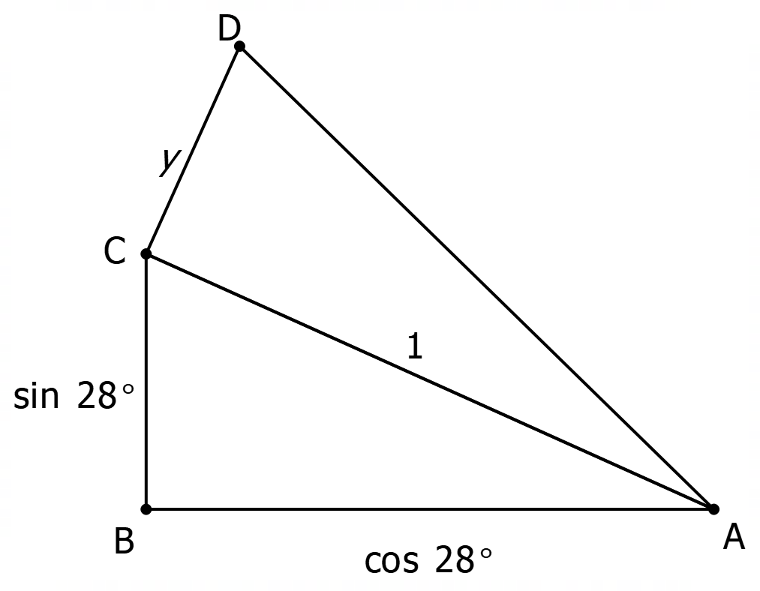
`
The best way to start this question is make one of the sides a standard length. In this case the best way is to make AC = 1. The other sides then determined relative to this.
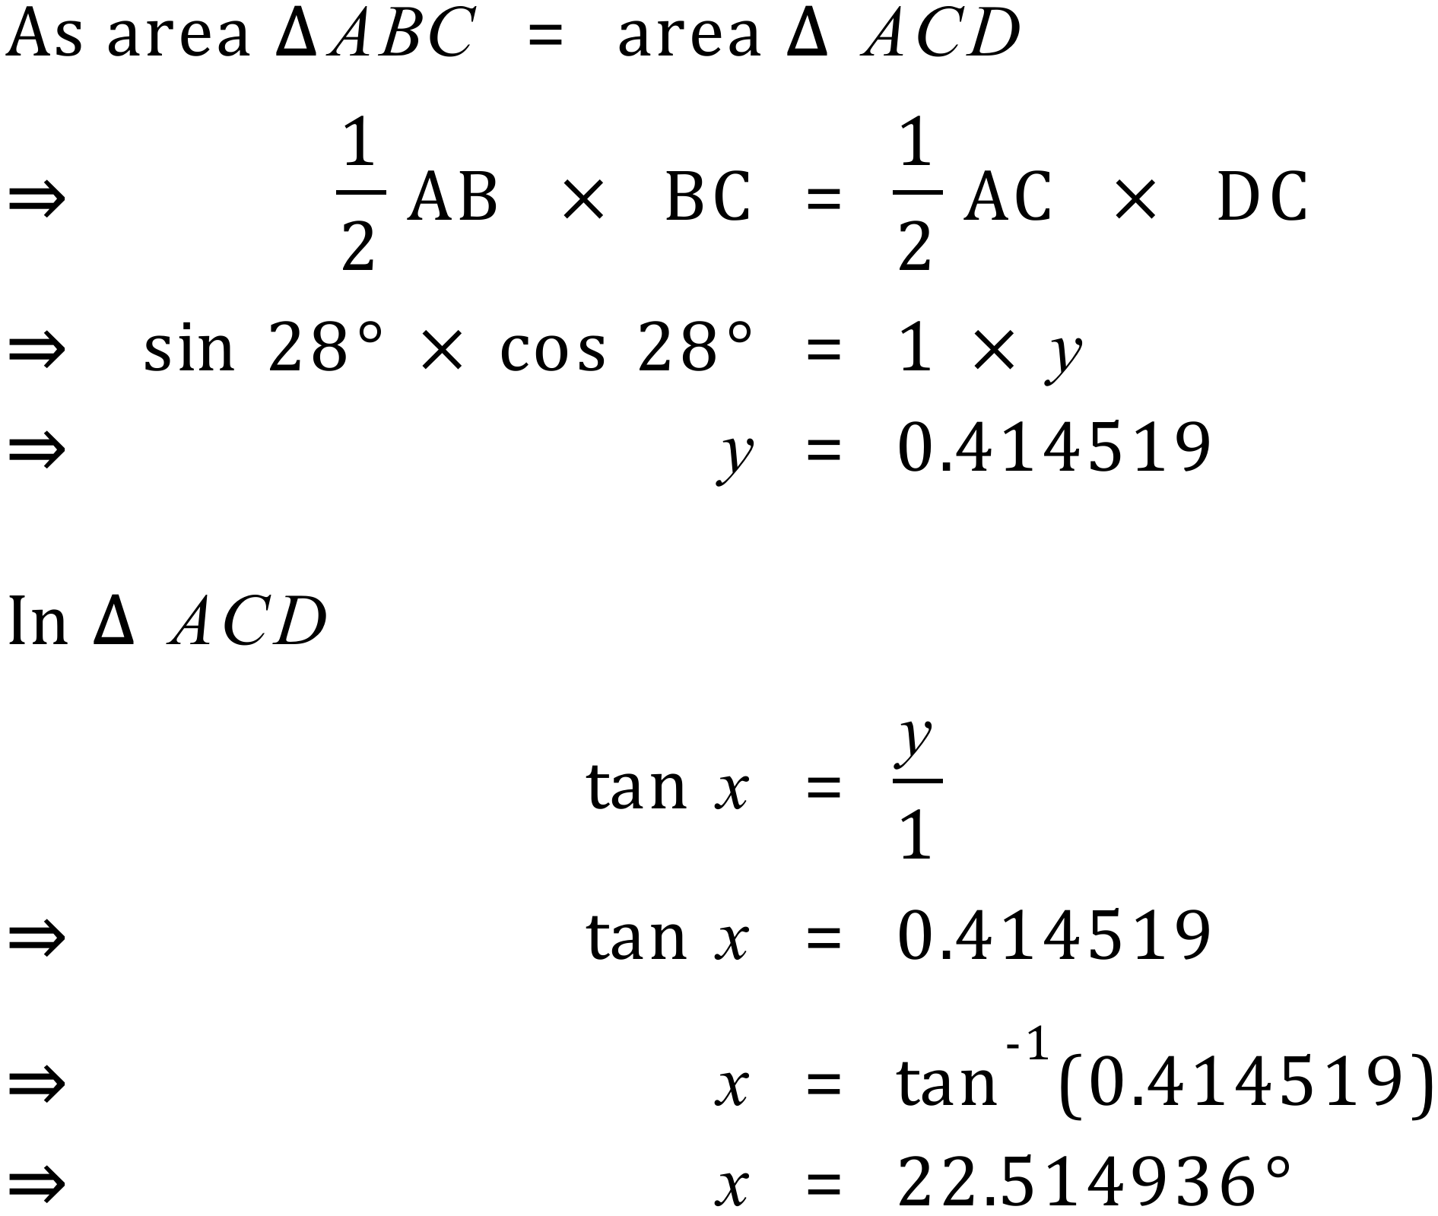

2. This time, the two triangles have the same PERIMETER. Again, how large is angle CAD?

In this question we use the same technique of setting the length of one side. In this case we need an extra side, z.
Using Pythagoras.
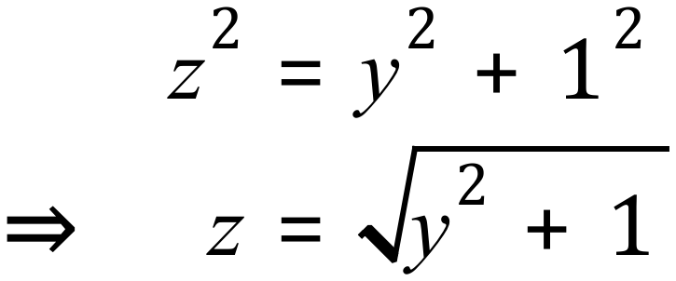
Because the perimeters of the triangles are the same
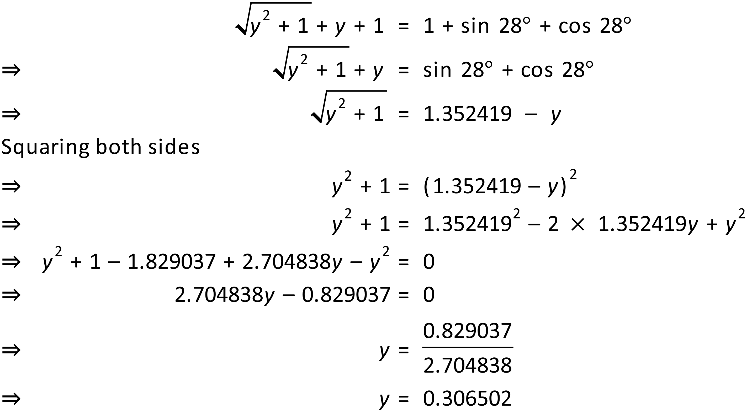
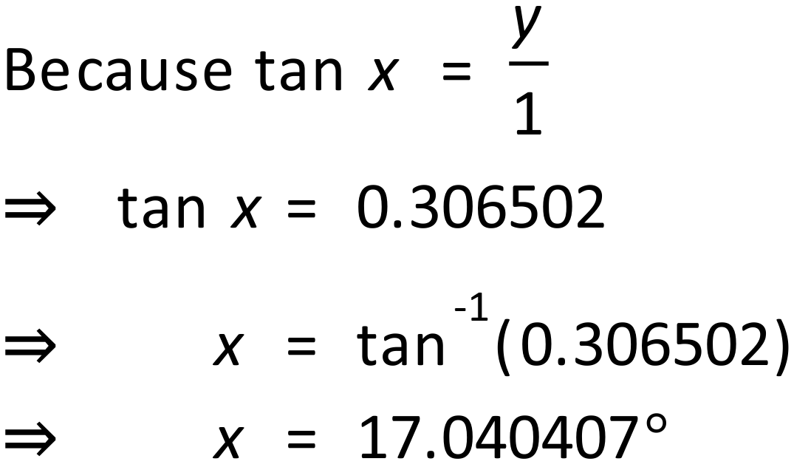
Therefore angle CAD is approximately degrees.
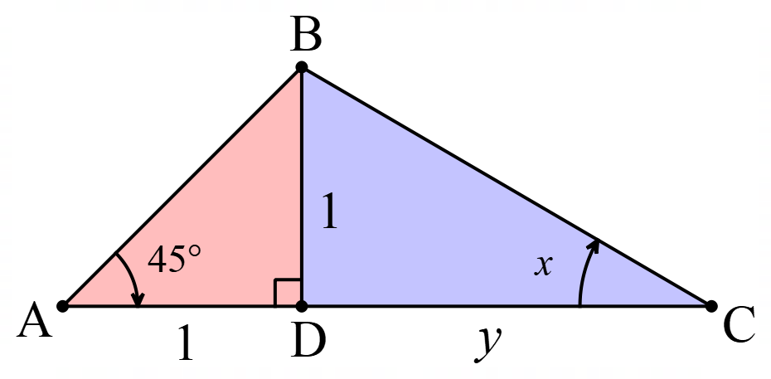

3. This triangle has been divided so that the area of the blue (right) side is 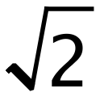 times the area of the red (left) side. What are the angles of triangle ABC?

Assume sides to be one as shown.
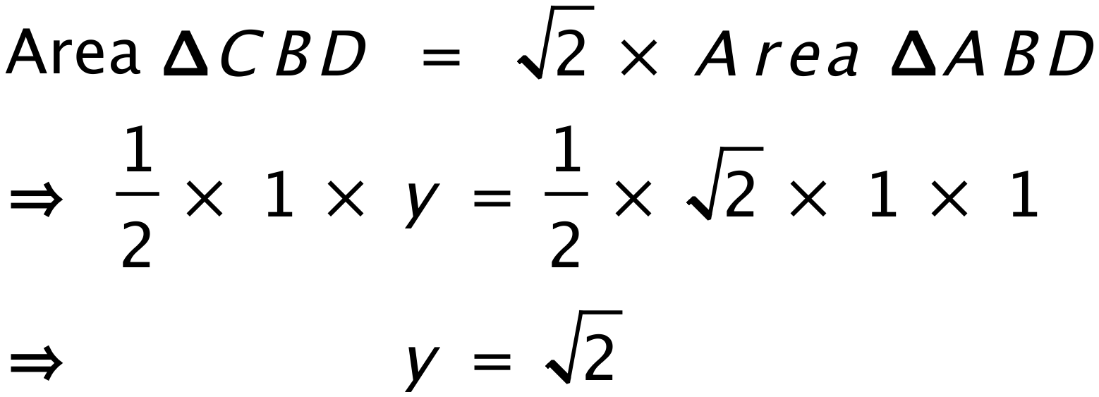
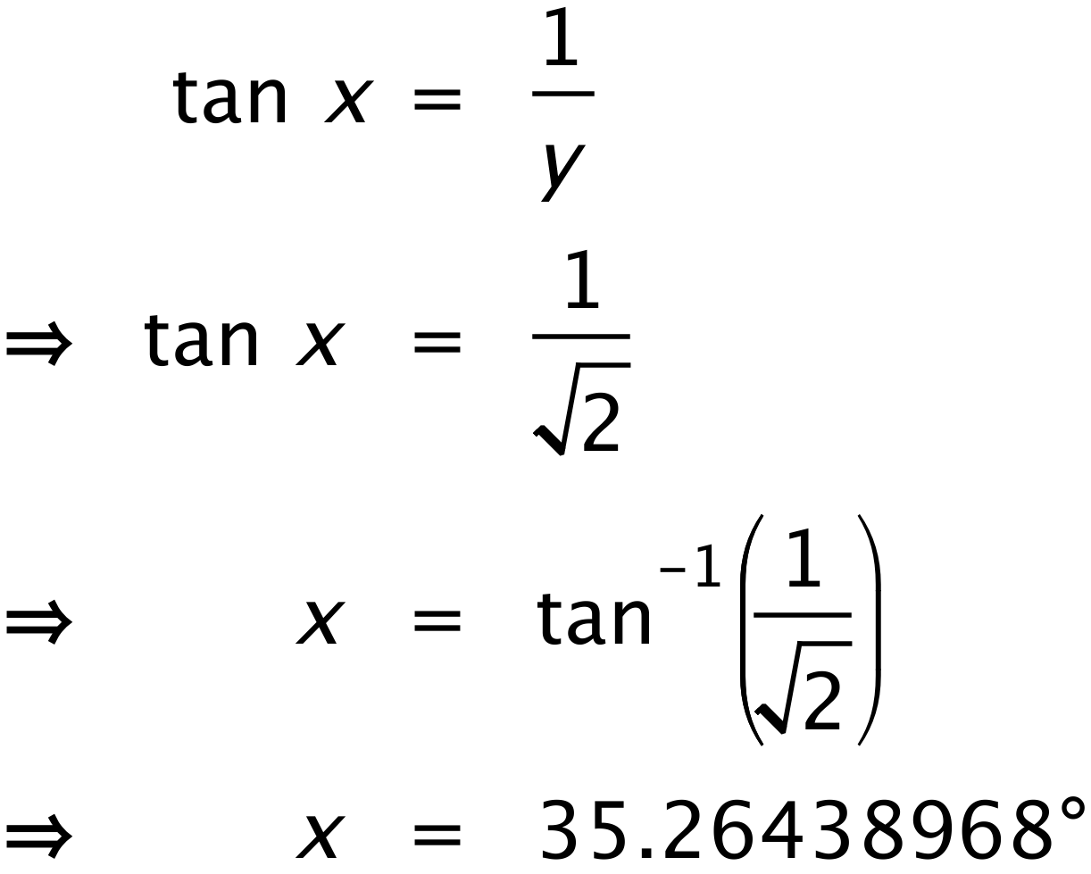 Angles are 45°, 35.3° and 99.7°

4. A cone is produced by removing a quarter of a circle and joining the two edges. When you look at the code from the side, what angle is formed by the two sloping sides?
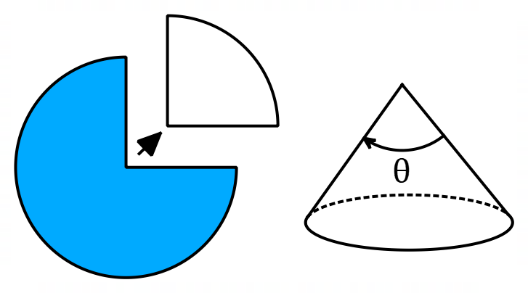
Assume that the radius of the original circle = 1
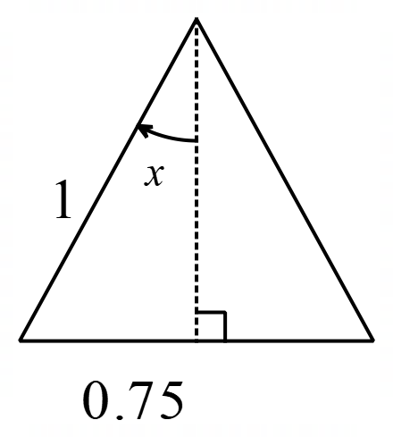
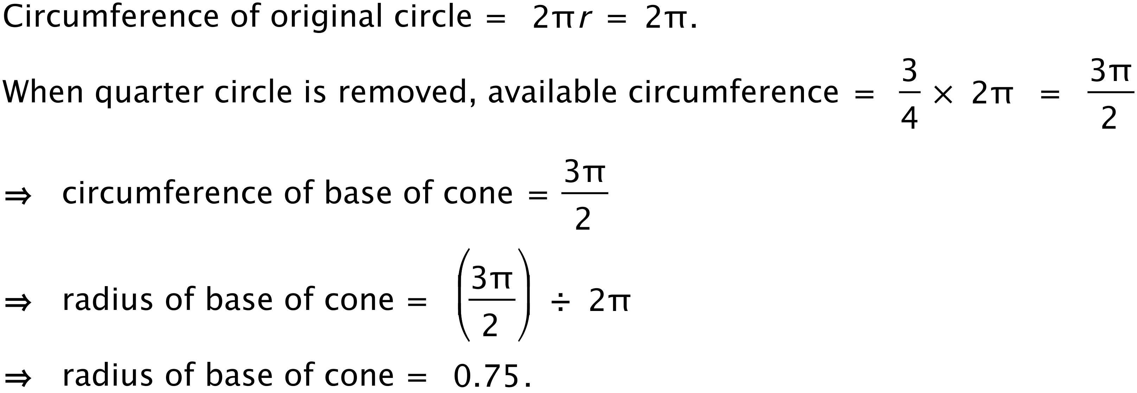

On this cross section of the cone you can see the radius of the base and the radius of the original circle which becomes the slope height of the cone.
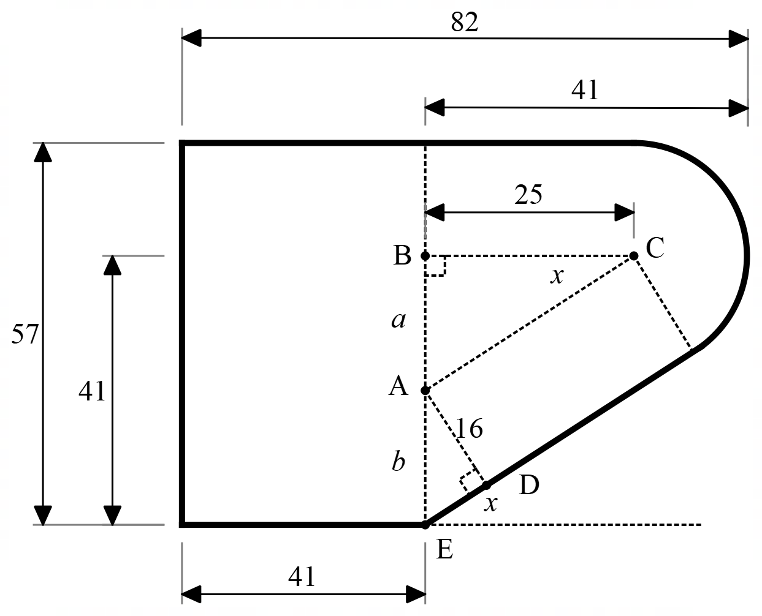
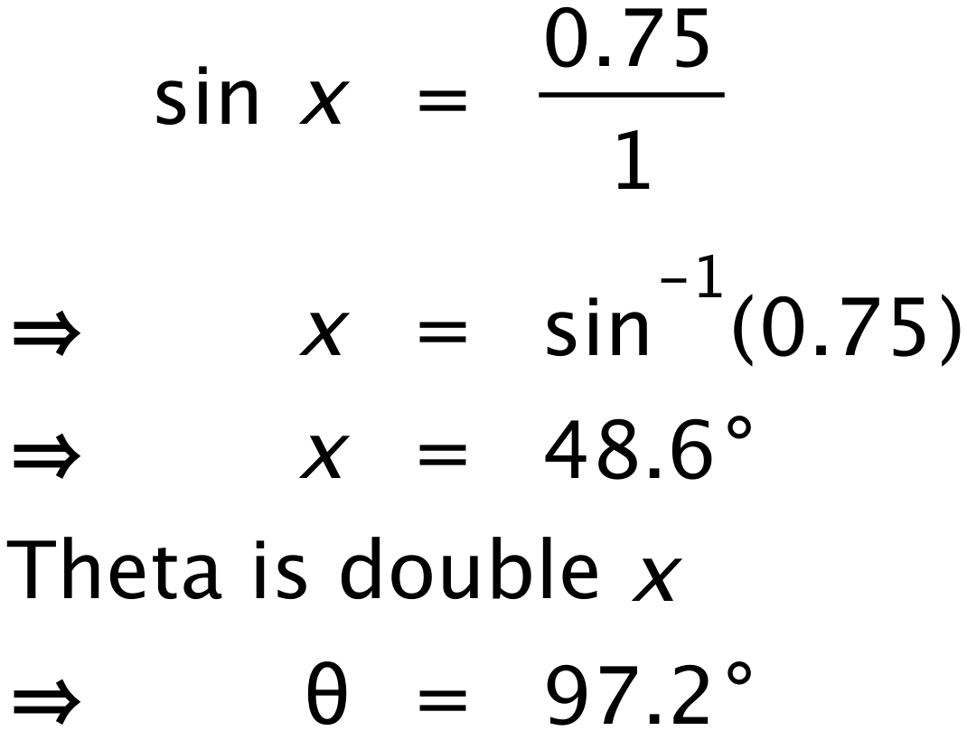
5. An kitchen supply company is designing a new edge-moulding for benchtops that has this design.
All distances are in millimetres. You can assume that the straight edges are tangential to the rounded corner. Find the size of angle x.

The solution to this question requires you to add a lot of extra lines to the diagram. From the diagram, with a little geometry, you can show that triangle ADE is similar to triangle CBA. You use this to solve the question.
